- Individual Productivity
  - Define
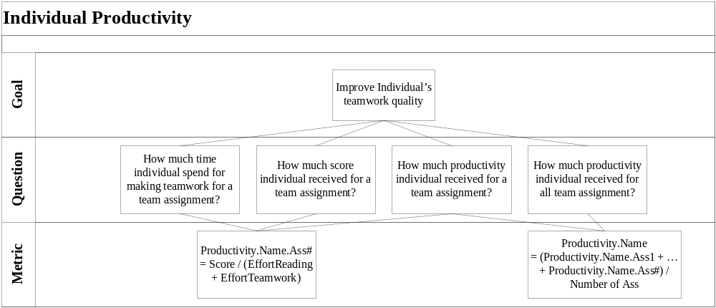
  - Result
Name | Team Assignment # | 2 | 3 | 4 | 5 | Individual Productivity
Le Dinh Thach Huyen | EffortReading | 5 | 1 | 2 | 2 | 11.58
Le Dinh Thach Huyen | EffortTeamwork | 4 | 2 | 5 | 7 | 11.58
Le Dinh Thach Huyen | Score | 70 | 45 | 93 | 92.5 | 11.58
Le Dinh Thach Huyen | Productivity.Ass# | 7.78 | 15 | 13.28 | 10.28 | 11.58
Dang Huy Son | EffortReading | 4 | 4 | 3 | 6 | 10.28
Dang Huy Son | EffortTeamwork | 4 | 5 | 5 | 8 | 10.28
Dang Huy Son | Score | 95 | 95 | 92.5 | 100 | 10.28
Dang Huy Son | Productivity.Ass# | 11.87 | 10.55 | 11.56 | 7.14 | 10.28
Do Minh Tam | EffortReading | 1.5 | 1.75 | 0 | 10 | 14.4
Do Minh Tam | EffortTeamwork | 8.5 | 1 | 9 | 4 | 14.4
Do Minh Tam | Score | 95 | 92.5 | 95 | 55 | 14.4
Do Minh Tam | Productivity.Ass# | 9.5 | 33.63 | 10.55 | 3.92 | 14.4
Nguyen Trung Tin | EffortReading | 9 | 2 | 4 | 2 | 12.65
Nguyen Trung Tin | EffortTeamwork | 2 | 0.5 | 3 | 4 | 12.65
Nguyen Trung Tin | Score | 72.5 | 50 | 92.5 | 65 | 12.65
Nguyen Trung Tin | Productivity.Ass# | 6.59 | 20 | 13.21 | 10.83 | 12.65
Le Thi Bich Van | EffortReading | 4 | 1 | 4 | 5.5 | 21.65
Le Thi Bich Van | EffortTeamwork | 12.5 | 0.75 | 0.45 | 8 | 21.65
Le Thi Bich Van | Score | 95 | 92.5 | 92.5 | 97.5 | 21.65
Le Thi Bich Van | Productivity.Ass# | 5.75 | 52.85 | 20.78 | 7.22 | 21.65

  - Improvement
- Team Productivity
  - Define
  - Result
  - Improvement

